# Introduction

The Ministry Safe plugin allows you to assign awareness trainings to your employees and volunteers and record the results in Rock. This allows you to easily keep track of which volunteers require training.

This plugin assumes you already have a Ministry Safe account. If you would like help configuring Ministry Safe, please contact the BEMA Information Technologies support at 877-817-7776.

# Overview

Bundled into the Ministry Safe Plugin are several new components that work together to assign and track Ministry Safe Trainings. Let’s take a look at these components.

**Ministry Safe Workflow** – This workflow can be launched from a person’s profile or from a connection request, and goes through the process of approving, submitting, and recording results from a Ministry Safe Training.

**Ministry Safe Attributes –** These are new attributes under the category *Ministry Safe* that will display on a user’s *Extended Attributes* page.

**Ministry Safe Badge** – This is a new badge that displays whether a user has taken a Ministry Safe training, as well as their score.

**RSR – Ministry Safe Training Administration –** This is a new Security Role geared towards approving Ministry Safe Trainings

**Ministry Safe User Page –** This page lists all past and ongoing Ministry Safe Trainings.

**Ministry Safe Webhook –** This plugin uses a webhook to receive updates from Ministry Safe, which means as soon as your users complete their training, their results will be posted to Rock!

# SETUP

To configure the plugin, we’ll need to configure Rock and Ministry Safe to communicate with each other, and then add people to the Ministry Safe Training Administration group.

### Setting Up The API Key

1. Log in to your Ministry Safe account, and then navigate to <https://safetysystem.ministrysafe.com/webhooks>.
2. Look at the Private API Key section. Copy down your API Key. If one doesn’t already exist, click the *Generate API Key* button to create one.

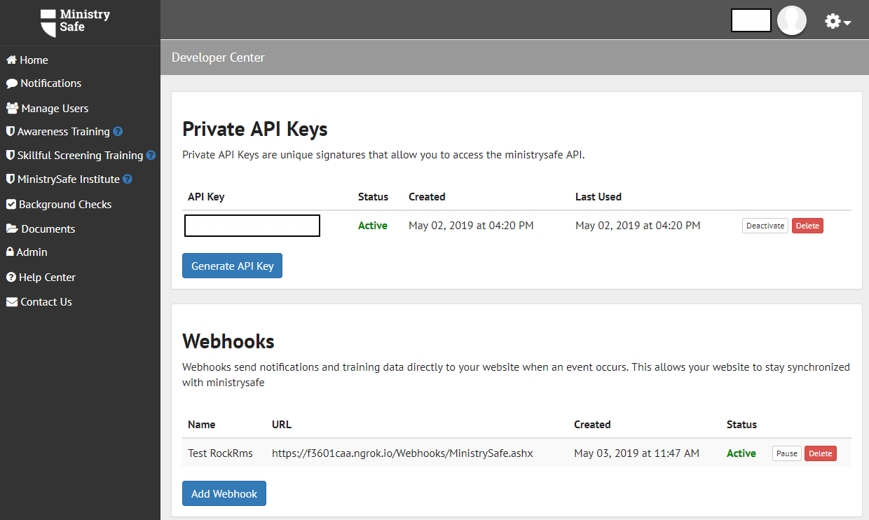

1. Next, scroll down a bit to the Webhooks section, and click the *Add Webhook* button.
   1. Add a name. This can be whatever you like, but we recommend *RockRMS*, for clarity.
   2. Add a URL in the format <https://[YourOrganizationUrl]/Webhooks/MinistrySafe.ashx>. For example, the Rock demo site would use the URL <https://rock.rocksolidchurchdemo.com/Webhooks/MinistrySafe.ashx>.
2. Go to RockRMS and navigate to General Settings > Global Attributes. Scroll down until you see the *Ministry Safe API Token* attribute. Past the API key from step 2 in here and click save.
3. RockRMS and Ministry Safe are now able to communicate with each other.

### Configuring the admin team

Much like how background checks in Rock go through the Background Check Administrators, Ministry Safe also ships with a security role of their own. These people oversee approving training requests that come in. Make sure you have at least one person in this role before using the plugin.

# Plugin Features

### Ministry Safe REquests

The Plugin will add a new workflow called ‘Ministry Safe Training Request’. It’s available from the Actions dropdown menu on the Person Profile Page by default, but you can also add it as a manually triggered workflow to connection requests.

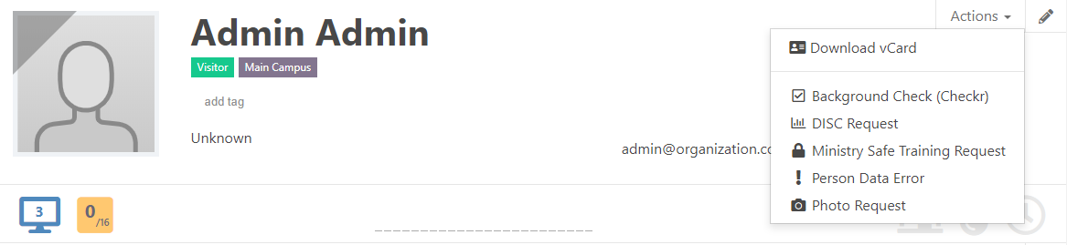

When launched, the employee will be asked to select a training and user type. After entering that information, the request will go to the *RSR – Ministry Safe Training Administrators* to be approved or denied. Once approved, a training will be created in Ministry Safe, and an email with a link to the training will be sent to the person the request was made for.

Once the training is completed, Ministry Safe will send Rock the results via the webhook we set up, and the training type, date, and score will be saved to the person’s profile.

### Ministry Safe Attributes and Badge

The plugin comes with new attributes displayed on the *Extended Attributes* page, as well as a new person profile badge, shown below.

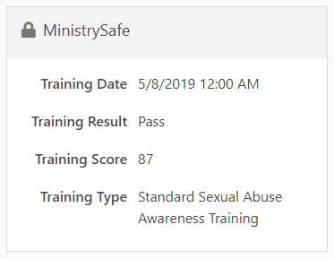 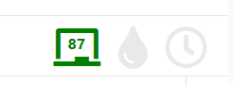

### Ministry Safe Defined Types

The Plugin also ships with two new Defined Types, *Ministry Safe Training Types* and *Ministry Safe User Types*.

### Ministry Safe USER Page

To see a full list of Ministry Safe Users and their scores, navigate to System Settings > Ministry Safe. Here you’ll see a list of all users, the date their training was created, the date it was completed, their score, and a link to the workflow associated with them.

